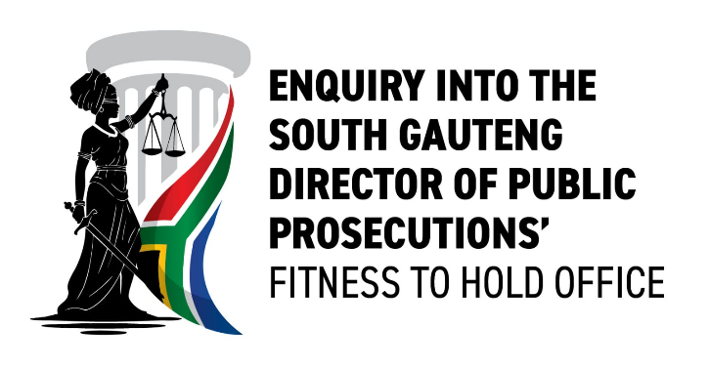
MEDIA STATEMENT
TO: ALL MEDIA/EDITORS
FOR IMMEDIATE RELEASE
31 October 2025

ENQUIRY INTO THE FITNESS TO HOLD OFFICE OF SOUTH GAUTENG DIRECTOR OF PUBLIC PROSECUTION READY TO COMMENCE HEARINGS
Enquiry in terms of Section 12(6) of the National Prosecuting Authority Act 32 of 1998 into the Fitness of Advocate Andrew Chauke to Hold the Office of Director of Public Prosecutions, South Gauteng, Announces Readiness to Commence
Pursuant to section 12(6)(a) of the National Prosecuting Authority Act 32 of 1998, an Enquiry into the fitness of Advocate Andrew Chauke to hold the office of Director of Public Prosecutions has been established.
The Enquiry is chaired by Retired Justice of the Constitutional Court Bess Nkabinde, who is assisted by Advocate Lizzy Baloyi-Mere SC and Attorney Ms Matshego Ramagaga as panellists. Advocate David Mohlamonyane SC and Attorney Ms Mabyana Thulare-Sebono serve as Evidence Leaders, with Advocate Phuti Setati as the Secretary to the Enquiry.
The seat of the Enquiry will be on the 29th Floor of the Salu Building, 316 Thabo Sehume Street, Pretoria, within the premises of the Department of Justice and Constitutional Development. The first sitting of the Enquiry will take place on Monday 17 November 2025 from 09:00.
The Enquiry will examine specified allegations relating to the exercise of prosecutorial discretion and compliance with the Constitution, the National Prosecuting Authority Act and prosecutorial policy, including whether Advocate Chauke is a fit and proper person to hold his office.
The Chairperson will submit her report to the President once the Enquiry has been completed. Further information regarding the Enquiry’s proceedings and schedule will be communicated in due course.
To uphold the integrity and decorum of the proceedings, members of the media will be allocated a designated workspace within the seat of the Enquiry. Media work and coverage must be conducted in a manner that is orderly and non-disruptive to the business of the Enquiry.
Members of the media who wish to cover the proceedings are invited to apply for accreditation by completing the attached accreditation form in full and returning it via email to Mr Tiyisela Mpuzana at MMpuzana@NkabindeInquiry.org.za or contact 073 149 7657. Due to space limitations, access will be granted only to accredited media on a first come first served basis.
Deadline for submission of media accreditation: Monday, 10 November 2025 at 16:00

Media Enquiries:
Mr. Tiyisela Mpuzana
Spokesperson
Enquiry Into South Gauteng Director of Public Prosecutions’ Fitness to Hold Office
Email: MMpuzana@NkabindeInquiry.org.za
Cell: 073 149 7657
www.NkabindeInquiry.org.za

